DBMS

LAB ASSIGNMENT - 6



Ananya Agarwal

102083036

2CO14

Q1) Check the structure of tables.

desc dept;

desc emp;

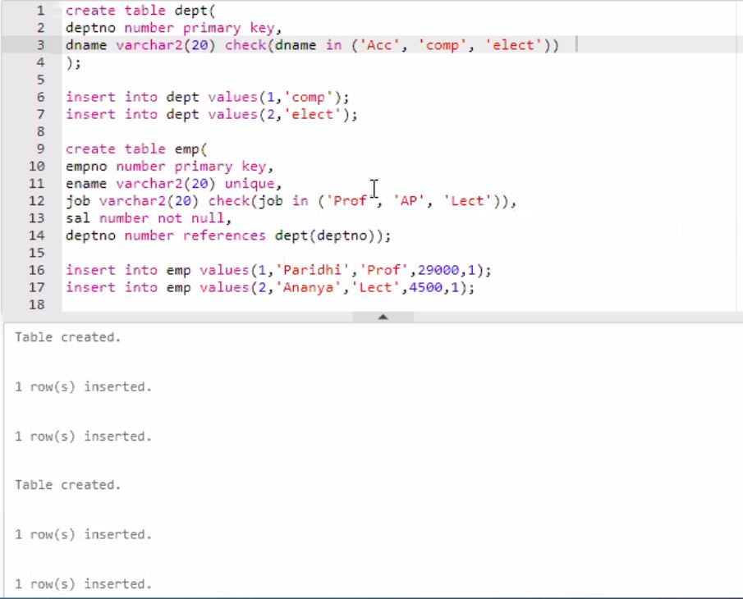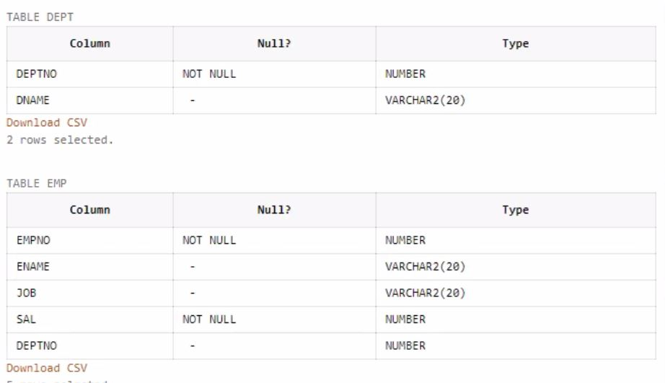

--ques2 Check the constraint name for applied constraints?

alter table emp

add constraint enam\_emp\_nn check (empno > 0);

select constraint\_name from user\_constraints;

For a specific table use:

SELECT constraint\_name FROM user\_cons\_columns where table\_name = 'emp';

E:\4th sem\DBMS\lab\ass\lovey dovey\2.JPG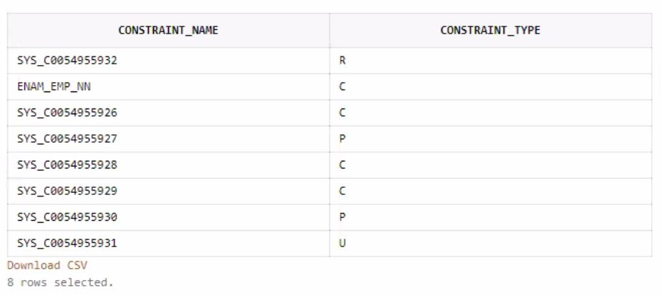

--ques3 Drop the unique constraint on ENAME

select constraint\_name, constraint\_type from user\_constraints;

alter table emp

drop constraint SYS\_C0054955931;

desc emp;

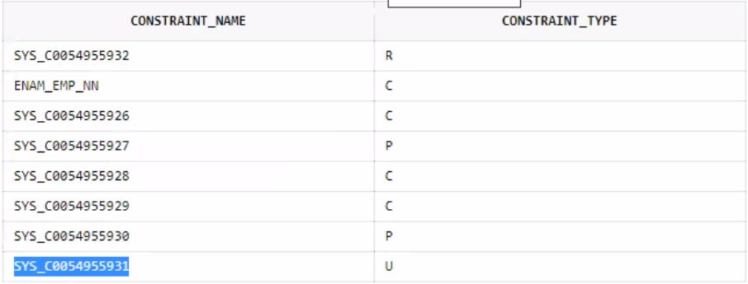

E:\4th sem\DBMS\lab\ass\lovey dovey\2.JPG

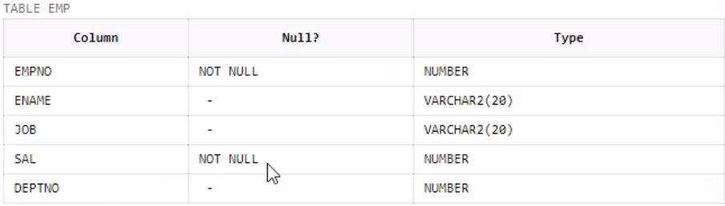

--ques4 Drop the Foreign Key constraint on DEPTNO

alter table employee

add constraint fk\_A foreign key(empno) references A(deptno);

alter table employee

drop constraint fk\_A;

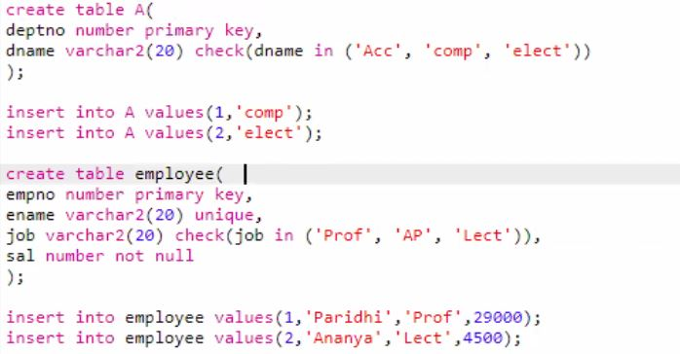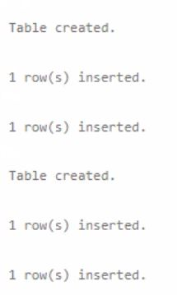

E:\4th sem\DBMS\lab\ass\lovey dovey\2.JPG

E:\4th sem\DBMS\lab\ass\lovey dovey\15.JPG

--ques5 Add Foreign Key constraint on DEPTNO

alter table employee

add constraint fk\_A foreign key(empno) references A(deptno);

E:\4th sem\DBMS\lab\ass\lovey dovey\2.JPG

--ques6 Change Data type of ENAME

alter table employee

modify(ename char(50));

E:\4th sem\DBMS\lab\ass\lovey dovey\2.JPG

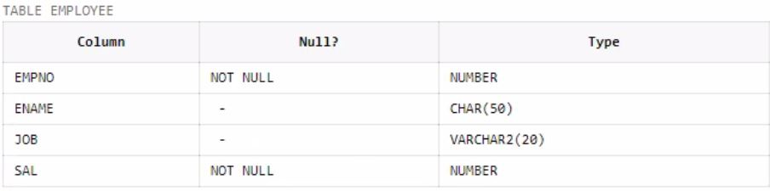

--ques7 Change width of DNAME

desc employee;

alter table employee

add (dname varchar(50));

desc employee;

alter table employee

modify(dname varchar(100));

desc employee;

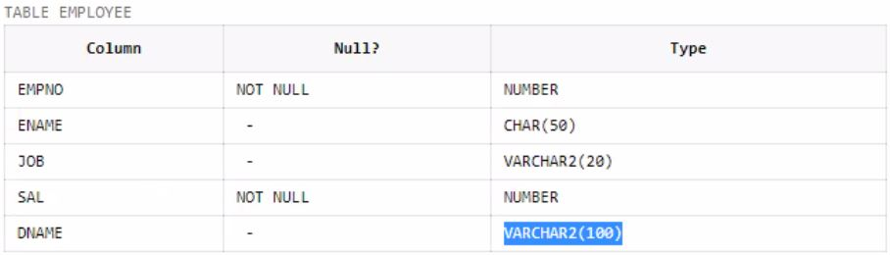

E:\4th sem\DBMS\lab\ass\lovey dovey\2.JPG

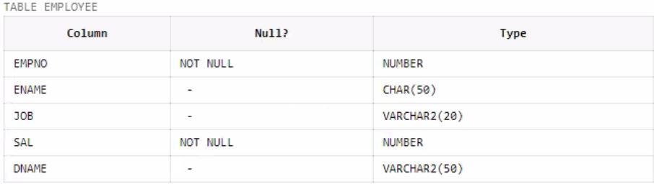

E:\4th sem\DBMS\lab\ass\lovey dovey\2.JPG

--ques 8 Add COMM column in EMP table

alter table employee

add (COMM number);

desc employee;

E:\4th sem\DBMS\lab\ass\lovey dovey\2.JPG

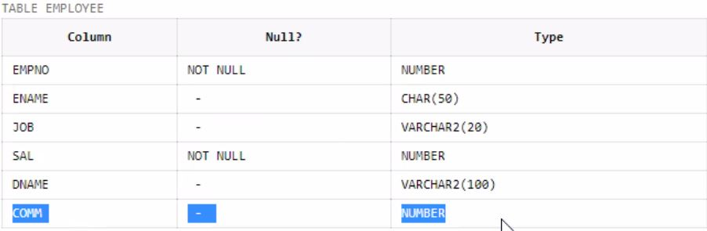

--ques 9 Drop CITY column from J table

create table J(

jno number primary key,

jname varchar2(20),

city varchar2(20));

desc J;

alter table J

drop column city;

desc J;

E:\4th sem\DBMS\lab\ass\table.JPG

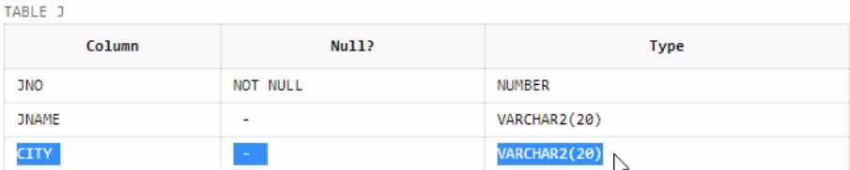

E:\4th sem\DBMS\lab\ass\lovey dovey\2.JPG

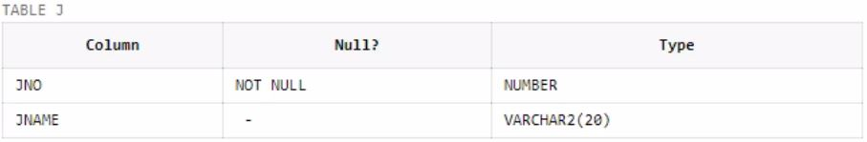

--ques 10 Create duplicate copy of EMP table

create table emp\_copy as select \* from emp;

desc emp\_copy;

select \* from emp\_copy;

E:\4th sem\DBMS\lab\ass\table.JPG

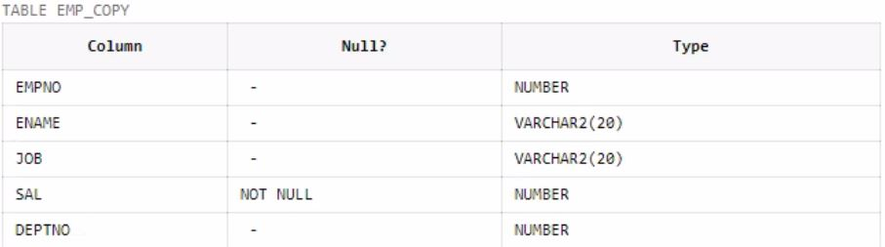

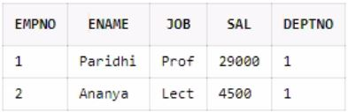

--ques 11 Copy structure of DEPT table in another table with different column names

create table emp\_dup(new\_deptno, new\_dname) as select \* from dept where 1=2;

desc emp\_dup;

E:\4th sem\DBMS\lab\ass\table.JPG

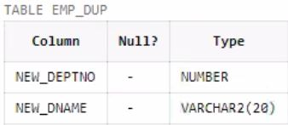

--ques 12 Change the name and job of the employee whose EMPNO =100

insert into emp values(100,'Ananya','Lect',4500,1);

update emp set ename = 'Vasana',job = 'AP' where empno = 100;

select \* from emp;

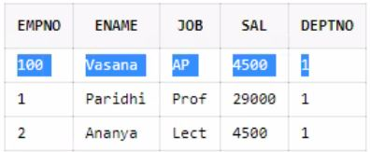

E:\4th sem\DBMS\lab\ass\lovey dovey\12.JPG

--ques 13 Delete the record of A who belong to computer department

delete from A where dname = 'comp';

select \* from A;

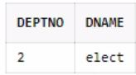

--ques 14 Drop DEPT Table

drop table dept cascade constraints;

desc dept;

E:\4th sem\DBMS\lab\ass\lovey dovey\15.JPG

E:\4th sem\DBMS\lab\ass\lovey dovey\14.JPG

--ques 15 Drop duplicate table of EMP table

drop table emp\_dup;

desc emp\_dup;

E:\4th sem\DBMS\lab\ass\lovey dovey\15_1.JPG